Project 1 Report

Project 1: ChocAn Requirements and Use-Case Modeling

Header Table
Member Name | CWID | Crimson Email | Hours Contributed
Molly O’Donnell | 12531046 | modonnell5@crimson.ua.edu | 1.5
Ian McClantoc | 12420291 | imcclantoc@crimson.ua.edu | 1.5
Ella Clark | 12312369 | ebclark1@crimson.ua.edu | 2
Rocket Jauriqui | 12450730 | ajjauriqui@crimson.ua.edu | 1.5
Zach Kennett | 12490982 | zakennett@crimson.ua.edu | 1.5
Lindsay Etheridge | 12525790 | lletheridge@crimson.ua.edu | 2

Task Distribution Table
Member Name | Tasks Performed | Percentage Contributed
Molly O’Donnell | - Set up requirements report  - Half of Use Case Descriptions | 17%
Ella Clark | - Glossary  - Ensure document-wide consistency | 17%
Ian McClantoc | Half Of Use Case Diagram | 17%
Zach Kennett | Half of Use Case Diagram | 17%
Rocket Jauriqui | Solution Paragraph | 17%
Lindsay Etheridge | Half of Use Case Descriptions | 17%

Project Requirements:
- Short paragraph (5 pts)
  - Detailed written solution.
  - This paragraph should specify any extra assumptions or your own clarifications if needed.
  - For each task, describe your solution. This paragraph should have explicit references to all submitted files as well as inline inclusion of images.
  - Failure to produce this paragraph will result in a penalty of 5% on your total grade.
  - Identify who the submitter is for the report as well.
  - There is no specified number of words for this paragraph.
- Glossary (5 pts)
  - After you get familiar with the domain of ChocAn, produce a glossary consisting of key terms and their brief explanation.
Glossary
- Use Case diagram (30 pts)
  - Identify the different Use Cases and draw a UML Use Case diagram of the system using UMLentino.
    - Make sure to use various features of use cases such as extends and includes.
- Use Case descriptions (35 pts)
  - For each Use Case, write the description of the Use Case in the document.
  - Make sure your use case labels in your diagram and use case description names match.
  - Use Case descriptions should follow the format:
Use case: Name of the Use Case.
Context: Brief description of the Use Case.
Actors: List of actors of the Use Case.
Main Success Scenario: The step-by-step description, such as:
1. Write step 1.
1.1. Write step 1.1.
2. Write step 2.
3. Write step 3.
Extensions: Possible alternatives to the steps you may think of (e.g.,
what happens if something goes wrong at this step), such as:
1a. Instead of step 1
3a. Instead of step 3.
3b. Other alternatives to step 3.

Solution Paragraph
Submitted by: Ian McClantoc - CS 200 Software Design and Engineering, Fall 2026

Overview: Our solution covers the design and implementation of a data processing system for ChocAn, a chocolate addiction anonymous group. This will cover all of the requirements stipulated in the contract, including member validation, file creation for billing and member/provider reports, and an interactive UI for all users.

Clarifications and Assumptions:
- Any input data that exceeds character limits (Name, Address) will be truncated and notify the user of the change. On this same note, fees will be assumed to be under $999 always and the weekly total will never surpass $99,999.
- Repeated service codes for the same patient on the same day will be assumed valid in the case of a follow-up appointment.
- In the use cases describing emailing the files, the data processing system does not and is not responsible for emailing, as it only creates the file for emailing. The Use Case Description only mentions the emailing as a step in the success scenario, not that it is an element in the data processing system we have designed.

Solution:
We have identified 5 main actors: the service provider, the ChocAn Operator, the ChocAn Manager, the ACME system, and an automated system. The provider is responsible for accessing the ChocAn provider terminal in order to set up a ChocAn member’s service. They are able to validate a member’s status, look up service codes, and bill ChocAn for the service provided. The ChocAn Operator is able to edit both providers and members’ data, such as updating validation status, billing, or adding and deleting users. The manager can request Summary reports and receive accounts payable reports. The automated system takes care of report generation and the weekly financial procedures to be reviewed by managers. The ACME system is the third party that processes membership payments, and updates the validity status of all members, whether disabling or reinstating status to users.
The system is able to handle input errors based on the fixed fields (100 character comment, 25 character address, etc) and prompt users when invalid entries are made. It can identify invalid or suspended member IDs and end the billing process during a provider interaction.
Our use case diagram below illustrates all of the relationships that allow for our data processing system to function and the descriptions expand on specific processes and cases to be considered. The glossary provides descriptions of all key terms relating to ChocAn, ACME, and the data processing system.

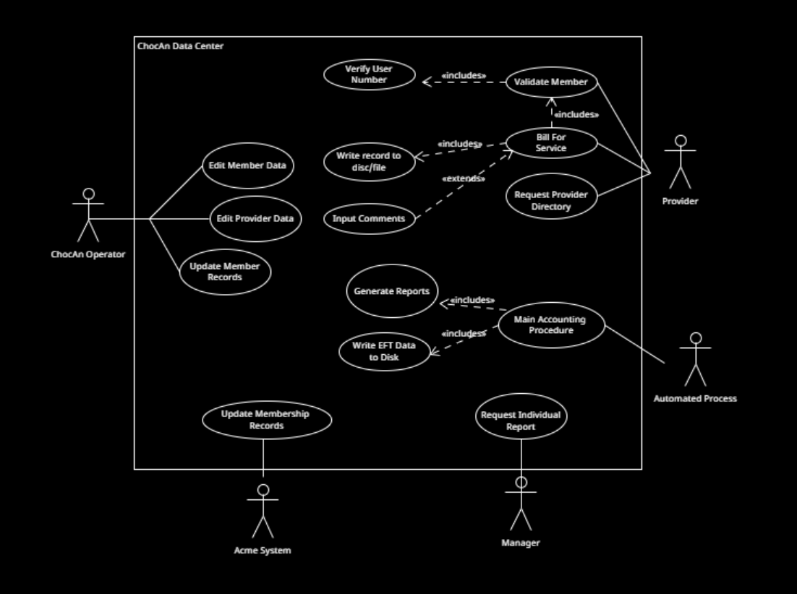

Glossary

Glossary

Acme Accounting Services | A third-party organization responsible for financial procedures such as recording payments of membership fees, suspending members whose fees are overdue, and reinstating suspended members who have now paid what is owing. (actor)
Chocoholics Anonymous (ChocAn) | An organization dedicated to helping people addicted  to chocolate in all its glorious forms
Date of service | The date the service was provided to the member (MM-DD-YYYY)
EFT | Electronic funds transfer
Interactive mode | The software status in which operators are allowed to add new members to ChocAn, to delete members who have resigned, and to update member records. Similarly, provider records are added, deleted, and updated.
Invalid number status | Member number invalid
Main Accounting Procedure | At midnight on Friday, the main accounting procedure is run at the ChocAn Data Center. It reads the week’s file of services provided and prints a number of reports.
Manager | An employee of ChocAn who has access to reports and data. (actor)
Member number | Nine-digit member number linked to a ChocAn member’s account
Member report | A list of services provided to that member, sorted in order of service date. The report, which is also sent as an e-mail attachment, includes:  Member name (25 characters).  Member number (9 digits).  Member street address (25 characters).  Member city (14 characters).  Member state (2 letters).  Member ZIP code (5 digits).  For each service provided, the following details are required:  Date of service (MM–DD–YYYY).  Provider name (25 characters).  Service name (20 characters)
Member suspended status | Member fees are owed (that is, the member has not paid  membership fees for at least a month) and member status has been set to suspended
Provider | A healthcare professional who provides services to a ChocAn member. (actor)
Provider Directory | An alphabetically ordered list of service names and corresponding service codes (6-digits) and fees
Provider number | Nine-digit number linked to a health care professional (provider)
Provider report | The list of services he or she provided to ChocAn members. To simplify the task of verification, the report contains the same information as that entered on the provider’s form, in the order that the data were received by the computer. At the end of the report is a summary including the number of consultations with members and the total fee for that week. That is, the fields of the report include:  Provider name (25 characters).  Provider number (9 digits).  Provider street address (25 characters).  Provider city (14 characters).  Provider state (2 letters).  Provider ZIP code (5 digits).  For each service provided, the following details are required:  Date of service (MM–DD–YYYY).  Date and time data were received by the computer (MM–DD–YYYY HH:MM:SS).  Member name (25 characters).  Member number (9 digits).  Service code (6 digits).  Fee to be paid (up to $999.99).  Total number of consultations with members (3 digits).  Total fee for week (up to $99,999.99).
Summary report | A report that lists every provider to be paid that week, the number of consultations each had, and his or her total fee for that week. Finally, the total number of providers who provided services, the total number of consultations, and the overall fee total are printed.
Validated status | Member number valid

Use Case Descriptions
Template:
Use case: Name of the Use Case.
Context: Brief description of the Use Case.
Actors: List of actors of the Use Case.
Main Success Scenario: The step-by-step description, such as:
1. Write step 1.
1.1. Write step 1.1.
2. Write step 2.
3. Write step 3.
Extensions: Possible alternatives to the steps you may think of (e.g.,
what happens if something goes wrong at this step), such as:
1a. Instead of step 1
3a. Instead of step 3.
3b. Other alternatives to step 3.

Use case: Switch On Provider Terminal
Context: When a provider’s terminal is switched on, the provider is asked to enter his or her provider number.
Actors: Provider
Main Success Scenario:
- Provider switches on terminal
- Terminal prompts provider to enter provider number
- Provider enters 9-digit provider number (via keyboard)
- System validated provider and unlocks terminal
Extensions:
3b. Provider number invalid
3b1. Throw Invalid Provider Number error
3b2. Repeat Step 3

Use case: Validate Member
Context: When a ChocAn Member goes to check into an appointment, the system needs to be able to check that the member is a valid member and is in good standing with ChocAn to ensure they’re allowed to use ChocAn services.
Actors: Provider
Main Success Scenario:
- Provider inputs 9-digit member number (via card swipe or keyboard)
- System queries data base for member account status
- System displays Validated on the screen
Extensions:
3a. Member number is invalid or nonexistent:
3a1. System displays Invalid Number and ends Use Case
3b. Member is suspended due to unpaid fees:
3b1: System displays Member Suspended and ends Use Case

Use case: Bill for Service
Context: After an appointment finishes, the provider needs to know how to bill the member and a record must be made of the appointment. The software takes billing info, validates service codes, shows service fee, and writes record to disk.
Actors: Provider
Main Success Scenario:
- Provider inputs 9-digit member number
- <<Include>> System executes Validate Member
  - System displays Validated
- Provider inputs date in MM-DD-YYYY format
- Provider uses provider directory to find 6-digit service code
- Provider inputs 6-digit service code
- <<Include>> System executes Look Up Service Code
  - System returns name of service.
- Provider verifies displayed service name matches provided service
- Provider inputs optional comments, up to 100 characters
- <<Include>> System executes Write Record to Disk
- System returns fee amount for specified service on display
Extensions:
2a. Member status is invalid
2a1. Return Invalid Number and end Use Case
2b. Member status is suspended
2b1. Return Member Suspended and end Use Case
6a. Entered service code is nonexistent:
6a1. Return Display Invalid Service Code Error
6a2. Provider re-enters valid service code
7a. Displayed service name is incorrect:
7a1. Provider cancels entry
7a2. Scenario repeats steps 5 through 7

Use case: Look Up Service Code
Context: Retrieves the corresponding service name and fee for a 6-digit service code entered during billing.
Actors: Provider
Main Success Scenario:
- System receives 6-digit service code input from provider
- Provider uses provider directory to find 6-digit service code
- System returns the corresponding service name (up to 20 characters) and associated fee amount
Extensions:
2a. Service code not found in directory:
2a1. System returns service lookup failure error

Use case: Write Record to Disk
Context: Writes billing details to disk file after a provider bills ChocAn for a service..
Actors: Provider
Main Success Scenario:
- System compiles billing details:
Current date and time (MM–DD–YYYY HH:MM:SS)
Date service was provided (MM–DD–YYYY)
Provider number (9 digits)
Member number (9 digits)
Service code (6 digits)
Comments (100 characters) (optional)
- System writes record to disk file
Extensions: N/A

Use case: Request Provider Directory
Context: Providers will often require the ChocAn provider directory, as it lists all covered services, the associated service code, and the fee charged for that service, so providers must be able to request this provider directory from ChocAn
Actors: Provider
Main Success Scenario:
- Provider requests directory
- System extracts directory data and creates file with alphabetically ordered list of service names, 6-digit service codes, and fees
- Software sends the Provider Directory to the provider as an e-mail attachment
Extensions: N/A

Use case: Main Accounting Procedure
Context: At midnight on Friday, the main accounting procedure is run at the ChocAn Data Center. It reads the week’s file of services provided and prints a number of reports.
Actors: Automated Process
Main Success Scenario:
- Automated Process triggers accounting run at midnight on Friday
- System reads the week’s file of services provided
- <<Include>> System executes Generate Member Reports
- System sends Member Report as email attachment
- <<Include>> System executes Generate Provider Reports
- System sends Provider Report as email attachment
- <<Include>> System executes Generate Summary Report
- System sends Summary Report as email attachment
- <<Include>> System executes Write EFT Data to Disk

Use case: Request Individual Report
Context: At any time during the week, a ChocAn manager can request that any individual report (Member Report, Provider Report, or Summary Report) be generated on demand.
Actors: Manager
Main Success Scenario:
- ChocAn Manager submits request for a specific report (Member, Provider, or Summary) via Data Center software
- System reads current week's service data
- System generates requested report
3.1. <<Include>> System executes Generate Member Reports, Generate Provider Reports, or Generate Summary Report
- System displays or delivers requested report to ChocAn Manager
Extensions:
2a. No service records exist for requested parameters:
2a1. System displays message indicating no data available and ends Use Case

Use case: Generate Member Reports
Context: Every week, members who used ChocAn services that week must receive a member report, sorted by date of service, that covers all the services they used in the last week. The reports will be sent as email attachments, but for our testing each report must simply be written to a document.
Actors: Automated Process
Main Success Scenario:
- System scans weekly service file for all members who consulted a provider
- System creates a report file for each member named with member name followed by report date
- System writes header to file formatted like below:
Member name (25 characters)
Member number (9 digits)
Member street address (25 characters)
Member city (14 characters)
Member state (2 letters)
Member ZIP code (5 digits)
- System writes list of services sorted by service date:
Date of service (MM–DD–YYYY)
Provider name (25 characters)
Service name (20 characters)
Extensions: N/A

Use case: Generate Provider Reports
Context: Every week, providers who gave ChocAn-covered services must receive a report summarizing the services they provided and how much they are to be paid by ChocAn. The reports will be sent as email attachments.
Actors: Automated Process
Main Success Scenario:
- System scans weekly service file for all providers who billed ChocAn
- System creates report file for each provider named with provider name followed by report date
- System writes header to file formatted like below:
Provider name (25 characters)
Provider number (9 digits)
Provider street address (25 characters)
Provider city (14 characters)
Provider state (2 letters)
Provider ZIP code (5 digits)
- System writes list of services in order received:
Date of service (MM–DD–YYYY)
Date and time data were received by the computer (MM–DD–YYYY HH:MM:SS)
Member name (25 characters)
Member number (9 digits)
Service code (6 digits)
Fee to be paid (up to $999.99).
- System writes summary section at end of report:
Total number of consultations with members (3 digits)
Total fee for week (up to $99,999.99)
Extensions: N/A

Use case: Generate Summary Report
Context: Every week, a summary report must be provided to the manager for accounts payable with details on all providers to be paid that week, the number of consultations they had, and their total fee for the week.
Actors: Automated Process, Manager
Main Success Scenario:
- System compiles weekly accounts payable data
- System writes the following to the file for every provider to be paid this week:
Provider name
Number of consultations provided
Total fee for the week
- System writes final summary totals:
Total number of providers who provided services
Total number of consultations
Overall fee total
- System delivers summary report to accounts payable manager
Extensions: N/A

Use case: Write EFT Data to Disk
Context: At the end of the main accounting procedure, an Electronic Funds Transfer (EFT) file is written to disk so banking computers can later credit each provider’s bank account with the appropriate payout amount.
Actors: Automated Process
Main Success Scenario:
- System reads weekly payment amounts for each provider who billed ChocAn
- System generates EFT file containing:
Provider Name
9-digit Provider Number
Transfer Amount
- System writes EFT record to disk file storage for bank processing
Extensions: N/A

Use case: Edit Member Data
Context: During the day, the software at the ChocAn Data Center is run in interactive mode to allow operators to add new members, delete resigned members, and update member records.
Actors: ChocAn Operator
Main Success Scenario:
- Operator launches ChocAn Data Center software in interactive mode
- Operator selects operation to add new member, delete resigned member, or update member record
- Operator inputs or modifies member fields:
Member name (25 characters)
Member number (9 digits)
Member street address (25 characters)
Member city (14 characters)
Member state (2 letters)
Member ZIP code (5 digits)
- System updates and saves member record changes to database
Extensions: N/A

Use case: Edit Provider Data
Context: During the day, the software at the ChocAn Data Center is run in interactive mode to allow operators to add new providers, delete provider records, and update provider details.
Actors: ChocAn Operator
Main Success Scenario:
- Operator launches ChocAn Data Center software in interactive mode
- Operator selects operation to add new provider, delete provider, or update provider record
- Operator inputs or modifies provider fields:
Provider name (25 characters)
Provider number (9 digits)
Provider street address (25 characters)
Provider city (14 characters)
Provider state (2 letters)
Provider ZIP code (5 digits)
- System updates and saves provider record changes to database
Extensions: N/A

Use case: Update Membership Records
Context: Acme Accounting Services processes membership payments and updates ChocAn Data Center records each evening at 9 P.M. to suspend overdue members and reinstate paid members.
Actors: Acme System
Main Success Scenario:
- Acme System connects to ChocAn Data Center computer at 9 P.M.
- Acme System transmits membership fee payment records and status updates
- System processes updates to suspend overdue members and reinstate paid members in ChocAn database
Extensions: N/A

Application details
Functionalities:
Take input, output to print, write member reports to files (named: name_date.doc), write provider reports to files, write provider directory to file

Actors:
- Provider
- Manager
- Acme (accounting service)

Use Cases:
Check-in for appt.
→ provider number
→ member number
← return Validated if good, Invalid Number if bad, Member Suspended and amount due if suspended

Billing post-appt.
→ Member number
← return Validated if good, Invalid Number if bad, Member Suspended and amount due if suspended
Break process if bad
→ Date (MM-DD-YYYY)
- Provider uses provider directory to find 6 digit service code -
→ 6 digit service code
← Name of service (20 chars), error msg if invalid code
→ Verification that the service is correct
Repeat from 6 digit service code entering if wrong
→ Enter comments - up to 100 chars (optional)
- Write record to disc (file): -
Current date and time (MM–DD–YYYY HH:MM:SS).
Date service was provided (MM–DD–YYYY).
Provider number (9 digits).
Member number (9 digits).
Service code (6 digits).
Comments (100 characters) (optional).

← Fee for specified service

Request of Provider Directory
→ Request directory
← Send directory (must be alphabetically ordered list of service name, code, and fee)

Member Reports
← Write a list of services provided, ordered by service date
Includes:
Member name (25 characters).
Member number (9 digits).
Member street address (25 characters).
Member city (14 characters).
Member state (2 letters).
Member ZIP code (5 digits).
For each service provided, the following details are required:
Date of service (MM–DD–YYYY).
Provider name (25 characters).
Service name (20 characters).

Provider Reports
← Write a list of services provided by this provider
Services each include:
Current date time
Date of service
Member name and number
Service code
Fee to be paid
Summary at end includes:
Provider name (25 characters).
Provider number (9 digits).
Provider street address (25 characters).
Provider city (14 characters).
Provider state (2 letters).
Provider ZIP code (5 digits).
For each service provided, the following details are required:
Date of service (MM–DD–YYYY).
Date and time data were received by the computer (MM–DD–YYYY HH:MM:SS).
Member name (25 characters).
Member number (9 digits).
Service code (6 digits).
Fee to be paid (up to $999.99).
Total number of consultations with members (3 digits).
Total fee for week (up to $99,999.99).

EFT data record
← Set up with provider name, provider number, and amount to be transferred

Summary report for manager for accounts payable
←list of every provider to be paid that week, number of consultations each provider had, total fee for the week by provider
Also include summary:
Total number of providers who gave services
Total number of consultations
Overall fee total

Interactive Mode
- Add new members
- Delete members
- Update member records

- Add, delete, and update provider records

